Justin Ganzak
CS 345 James
Assignment 1
Page 1
CS 345 Week 1 Homework
Make sure your answers are in numerical order!
Answers are in yellow
1)
The primary reason we are using VirtualBox in this class is:
a)
Bodhi Linux expects to be installed as a virtual machine
b)
So we don’t accidentally trash our physical hard drive
c)
To better manage networking functionality
d)
You cannot install two operating systems on one physical hard drive
2)
If there is a networking problem, most times we can correct it by changing our VirtualBox
network adapter setting to:
a)
Bridged Adapter
b)
Host-only Adapter
c)
Internal Network
d)
NAT
3)
The _____ partition is created during the installation process to provide a location for Linux to
store information from main memory when main memory gets full.
a)
empty
b)
null
c)
scratch
d)
swap
4)
Explain three reasons why would you might want to place Linux on multiple partitions.
The first reason you may want to create multiple partitions is because if a drive goes bad, you
only lose a portion and can backup/restore each partition individually. The second reason is that
the smaller partitions do not take as long to fsck due to the smaller size. Having the operating
system/files spread over several disks may increase performance. Lastly, when placing the core
OS on a separate partition, it allows you to update the OS without disturbing anything else. Also,
if user applications or files fill up their own partition, this will not stop the OS from operating
due to it having space within it’s own partition.
5)
To get a network address automatically assigned to your Linux machine, in most cases you
should use:
a)
BootAddr
b)
DHCP
c)
DNS
d)
StatAddr
Justin Ganzak
CS 345 James
Assignment 1
Page 2
6)
Typically we make the swap partition ___ time(s) the amount of RAM in the computer:
a)
one
b)
two
c)
four
d)
It doesn’t matter
7)
The command that will launch the GUI from the command line is:
a)
bodhiX start
b)
lightdm start
c)
start bodhiX
d)
start lightdm
8)
After the installation process is complete, what user account should be created for
administration work?
a)
reguser
b)
root
c)
sys
d)
system
9)
What service should be installed so that we can connect to the Linux computer remotely?
a)
Netstat
b)
Putty
c)
SSH
d)
Telnet
10) What is the name of the editor that you should learn to use as the least common denominator
for all Unix/Linux systems? (Just the command name is fine)
nano or pico
11) Install Linux and then paste in a screenshot to prove you have successfully installed Linux on
your system.
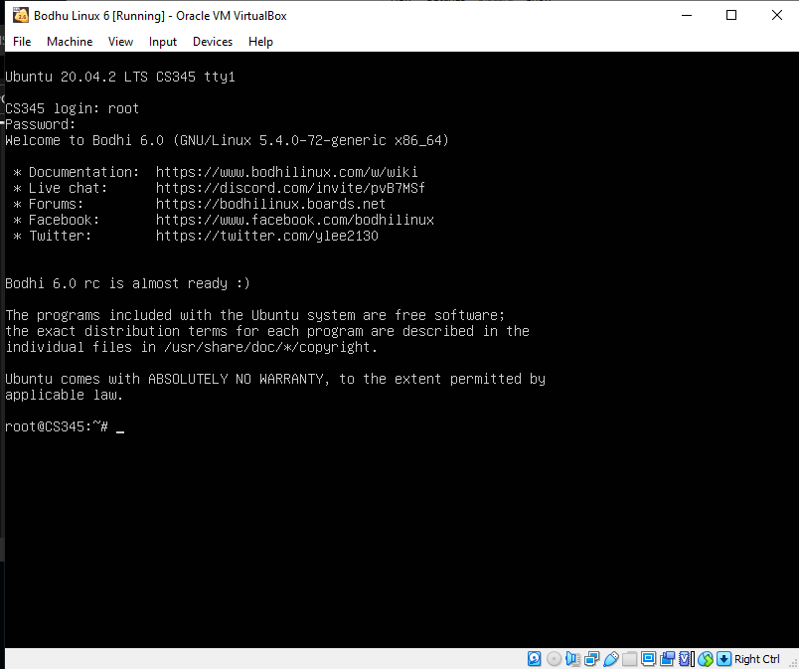
Justin Ganzak
CS 345 James
Assignment 1
Page 3
12) Show how long your system has been running and what processes are running on it. (Run the
commands and show your output – no screenshots!)
root@CS345:~# uptime
18:18:40 up 2 min, 2 users, load average: 0.00, 0.00, 0.00
root@CS345:~#
root@CS345:~# ps
PID TTY TIME CMD
767 pts/0 00:00:00 bash
776 pts/0 00:00:00 ps
root@CS345:~#
Justin Ganzak
CS 345 James
Assignment 1
Page 4
13) Show how to get help on the apropos command. (Run the command and show your output –
no screenshots!)
root@CS345:~# apropos --help Usage: apropos [OPTION...] KEYWORD...
-d, --debug emit debugging messages
-v, --verbose print verbose warning messages
-e, --exact search each keyword for exact match
-r, --regex interpret each keyword as a regex
-w, --wildcard the keyword(s) contain wildcards
.
.
.
The --regex option is enabled by default.
Report bugs to cjwatson@debian.org.
root@CS345:~#
14) Show the output from who, w and whoami – explain the difference between the three
commands. (Run the commands and show your output – no screenshots!)
The who command shows who is on the system. The w command shows who is on the system and what
they are doing. The whoami command checks who the user is logged on as.
root@CS345:~# who
root tty1 2022-05-15 18:16
root pts/0 2022-05-15 18:17 (192.168.1.13)
root@CS345:~# w
18:20:46 up 4 min, 2 users, load average: 0.00, 0.00, 0.00
USER TTY FROM LOGIN@ IDLE JCPU PCPU WHAT
root tty1 - 18:16 4:00 0.01s 0.00s -bash
root pts/0 192.168.1.13 18:17 5.00s 0.01s 0.00s w
root@CS345:~# whoami
root
root@CS345:~#
15) Prove that your installed Linux system has network access. Your “real” PC has to be able to
access the Internet. Once it can, then you should have the ability to ping other computers from
the Linux system. (Run the command and show your output – no screenshots!)
Justin Ganzak
CS 345 James
Assignment 1
Page 5
root@CS345:~# ping google.com
PING google.com (142.250.191.206) 56(84) bytes of data.
64 bytes from ord38s31-in-f14.1e100.net (142.250.191.206): icmp_seq=1 ttl=112 time=15.7 ms
64 bytes from ord38s31-in-f14.1e100.net (142.250.191.206): icmp_seq=2 ttl=112 time=15.2 ms
64 bytes from ord38s31-in-f14.1e100.net (142.250.191.206): icmp_seq=3 ttl=112 time=25.8 ms
64 bytes from ord38s31-in-f14.1e100.net (142.250.191.206): icmp_seq=4 ttl=112 time=14.6 ms
64 bytes from ord38s31-in-f14.1e100.net (142.250.191.206): icmp_seq=5 ttl=112 time=14.7 ms
64 bytes from ord38s31-in-f14.1e100.net (142.250.191.206): icmp_seq=6 ttl=112 time=18.8 ms
64 bytes from ord38s31-in-f14.1e100.net (142.250.191.206): icmp_seq=7 ttl=112 time=14.5 ms
64 bytes from ord38s31-in-f14.1e100.net (142.250.191.206): icmp_seq=8 ttl=112 time=15.2 ms
64 bytes from ord38s31-in-f14.1e100.net (142.250.191.206): icmp_seq=9 ttl=112 time=15.0 ms
64 bytes from ord38s31-in-f14.1e100.net (142.250.191.206): icmp_seq=10 ttl=112 time=14.6 ms
64 bytes from ord38s31-in-f14.1e100.net (142.250.191.206): icmp_seq=11 ttl=112 time=16.6 ms
64 bytes from ord38s31-in-f14.1e100.net (142.250.191.206): icmp_seq=12 ttl=112 time=14.8 ms
64 bytes from ord38s31-in-f14.1e100.net (142.250.191.206): icmp_seq=13 ttl=112 time=14.8 ms
64 bytes from ord38s31-in-f14.1e100.net (142.250.191.206): icmp_seq=14 ttl=112 time=15.6 ms
64 bytes from ord38s31-in-f14.1e100.net (142.250.191.206): icmp_seq=15 ttl=112 time=16.1 ms
.
.
.
--- google.com ping statistics ---
105 packets transmitted, 105 received, 0% packet loss, time 104151ms
rtt min/avg/max/mdev = 14.444/15.674/25.797/1.832 ms
root@CS345:~#

